# Algorithm for file updates in Python

## Project description

In this exercise, the task was to write an algorithm using the Python programming language which updates a file containing a list of IP addresses, having removed a subset of those addresses which should no longer be allowed to access the network or resource. Python is a general-purpose programming language, which means that it can be used to accomplish a wide range of different tasks.

Python can be used to automate long-running processes in cybersecurity, which would otherwise take a long time to perform manually by hand. This saves time as the programmer is now free to perform other tasks while the code runs.

## Open the file that contains the allow list

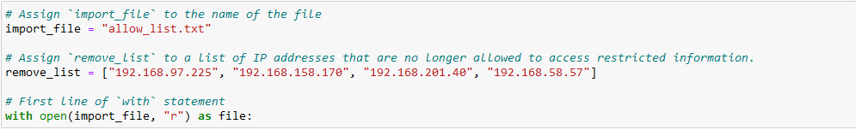

* Details on using a *with* statement and the *open()* function in your algorithm
* Explanations of the syntax, functions, and keywords in the code

## Read the file contents

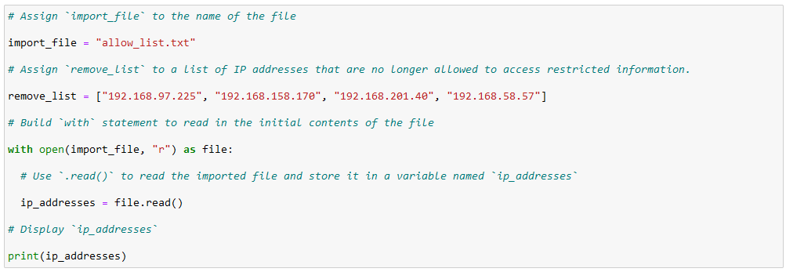

* Details on using the *.read()* and *.write()* methods in your algorithm
* Explanations of the syntax, functions, and keywords in the code

## Convert the string into a list

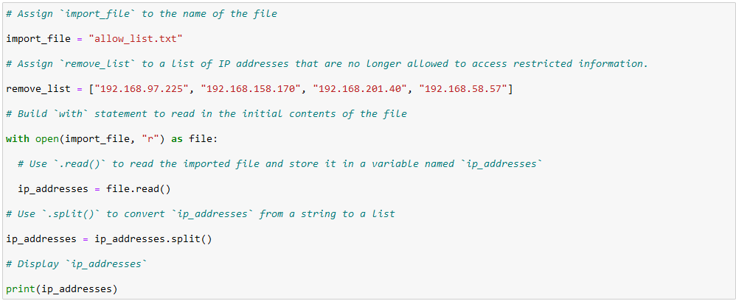

* Details on using the *.split()* method in your algorithm
* Explanations of the syntax, functions, and keywords in the code

## Iterate through the remove list

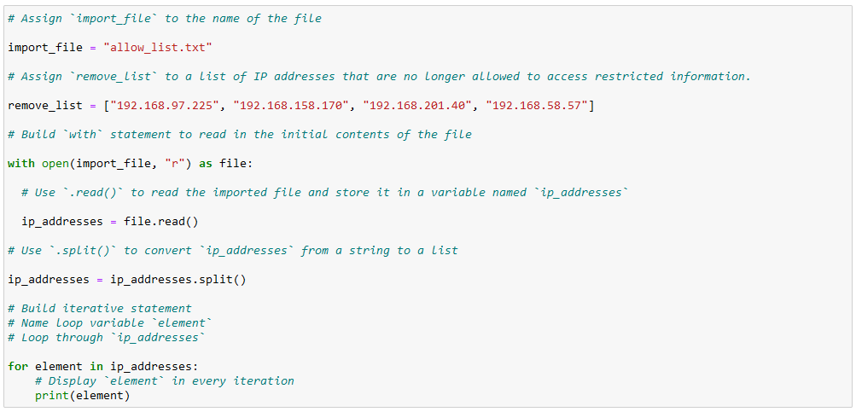

* Details on using a *for* loop in your algorithm
* Explanations of the syntax, functions, and keywords in the code

## Remove IP addresses that are on the remove list

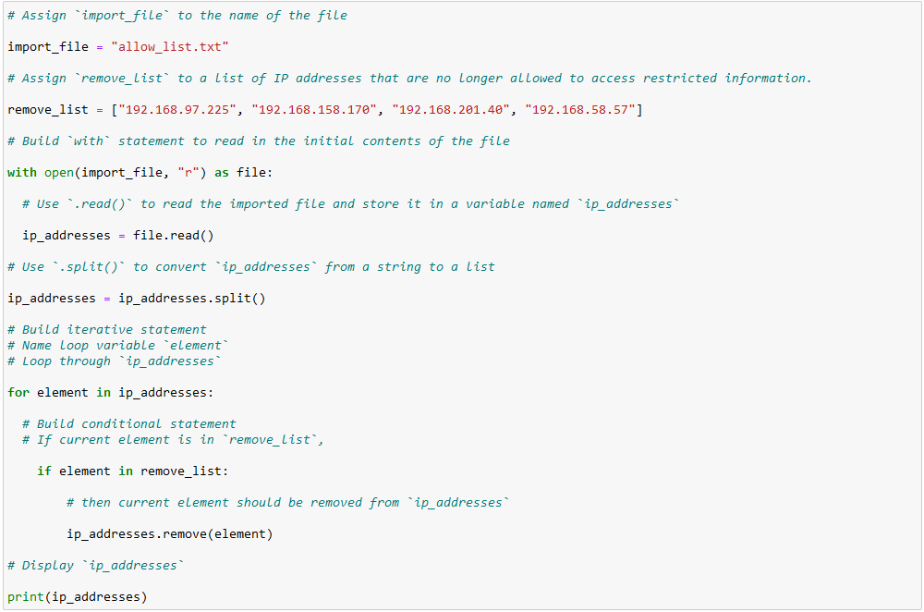

* Details on using the *.remove()* method in your algorithm
* Explanations of the syntax, functions, and keywords in the code

## Update the file with the revised list of IP addresses

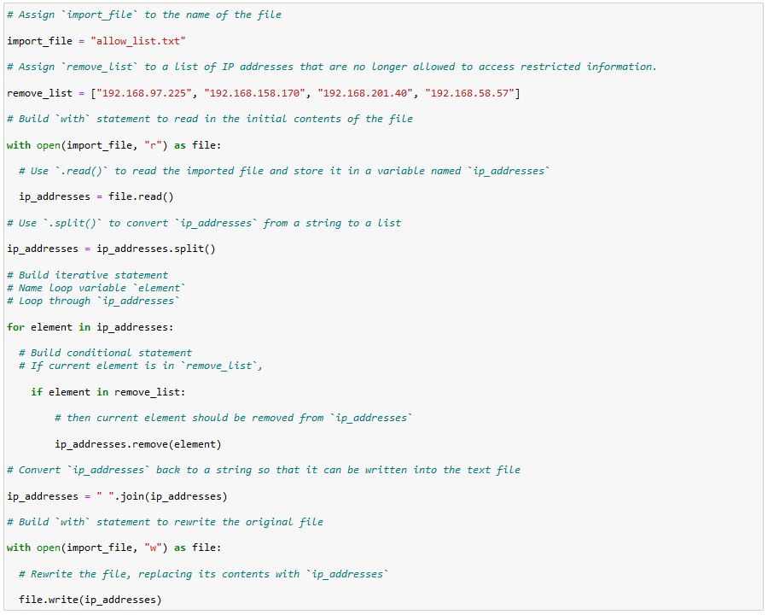

* Details on using the *.read()* and *.write()* methods in your algorithm
* Explanations of the syntax, functions, and keywords in the code

## Summary

In this task, the goal was to take a list of IP addresses, and update it using Python, with the goal of denying access to a set of IP addresses that needed access removed. To accomplish this task, the addresses were read into a file, and parsed into a format that was easier to work with. The unfavourable addresses were then removed from the list of IPs, and the file was updated to reflect the changes made.